**Accessibility to Medical Care during the Obama Administration**

“Writing is an act of ego” – William Zinsser

As we near the 2020 elections, and people gear up to let fly their opinions and discuss the aftermath, nervous about the possible outcomes, there are many questions left unaddressed that settle into the background. Just as sports become a ritual for bonding and hooliganism over the actual love of the game, political races can take the form of a boxing match rather than one of social dialogue.

At times like these it is important to note that many of our state institutions work hard to produce metrics relevant to answering the very same questions our leaders seek to address in 2-minute punchy quotes and soundbites. The breadth of their dialogue during events, debates, and speeches, becomes an occasion to pander to the views of a populace, and a lot of critical direction-setting and agenda setting gets lost in the background.

One of the key sources of information on social statistics is doubtlessly the census bureau. The CPS or current population statistics offer us an insight into samples of the American population, and how they fare on various metrics. For this brief insight, we have decided to focus on medical insurance for the various races. Additionally, we could have examined how medical coverage varies by state, or how coverage for American’s compares to that of its neighbors.

Medical insurance is a perennial issue addressed by social scientists and scientists alike, across the spectrum. It truly is an area where swing voter can be swayed to vote differently, and is thus a key bipartisan issue. Studies have shown that people race is a significant predictor of how they vote, especially in the case of black voters. It is therefore important to examine how people of various backgrounds have fared with respect to their medical insurance coverage in the past several years.

In order to examine this concern, we turn to the CPS data segmented by Race. The aggregated tables provide the relevant data points necessary for charting the graphs below.

**Overall Cover Rates, by Race**

For the analysis at hand, I have chosen to focus on the following four categories – White, Black, Asian, and Hispanic. While absolute numbers vary by a large margin, especially with nearly 3/4 of the U.S. population constituted by whites, some of the proportions we present hope to illuminate the picture more clearly.

The purpose of this analysis is more to present the data objectively than to make any bold claims about the sources of any apparent disparities. Additionally, disparities may vary widely in their source, from socioeconomic status, to cultural reasons, and from immigration status, to state.

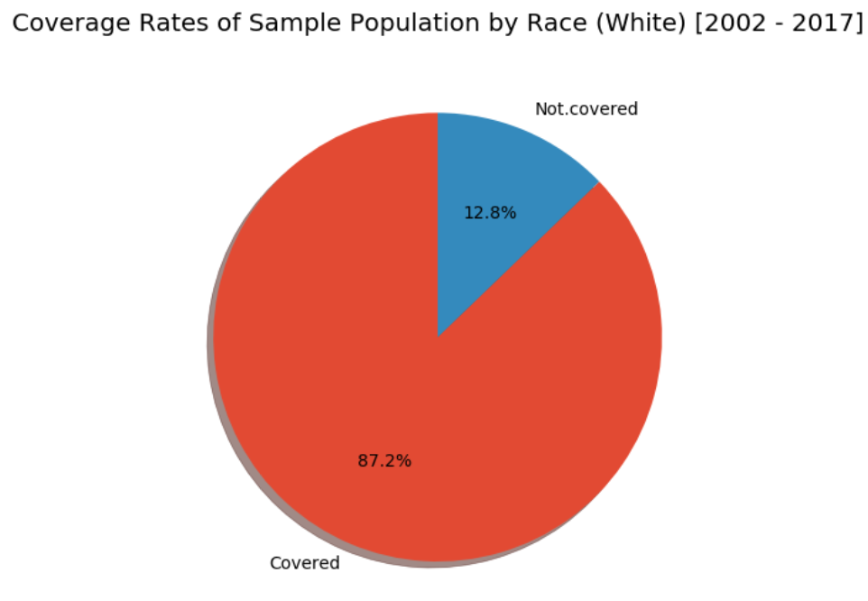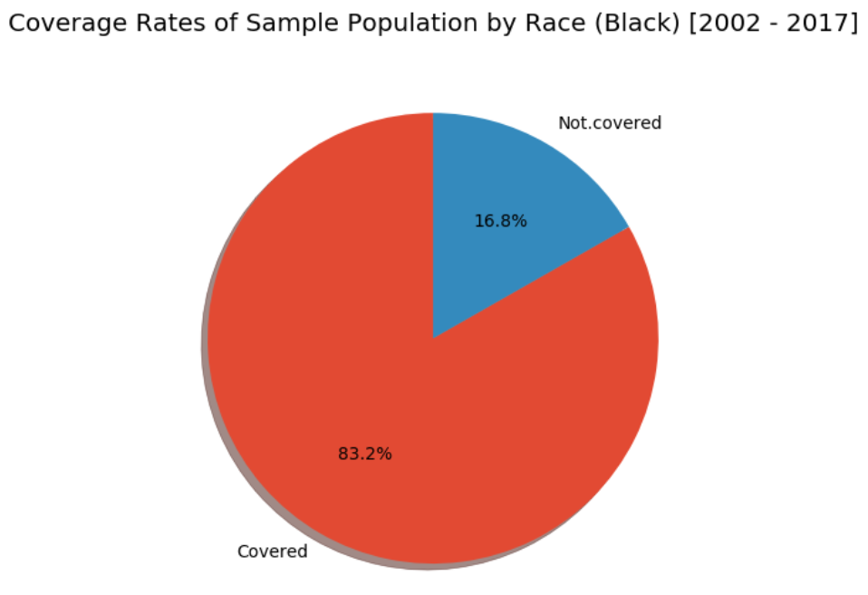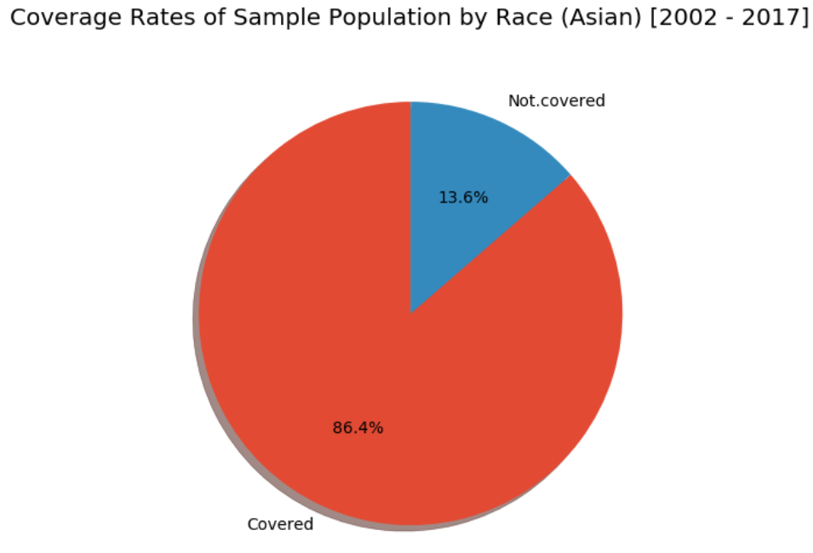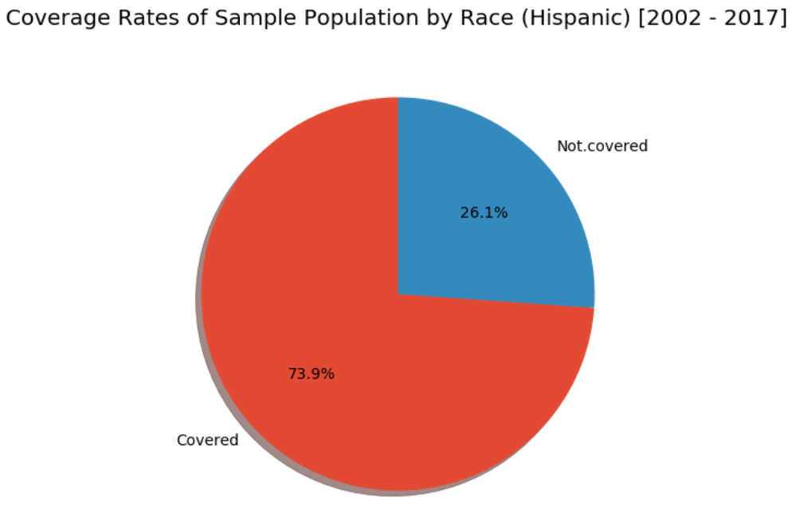

The presented charts are rather self-explanatory. The ‘White’ category has the lowest number of uninsured populations, followed by those categorized as Asian, followed by Black, and lastly by Hispanic. More than 1/4 of all Hispanic people present in the sample are uninsured. If sampling was conducted randomly, this may reflect migrant labor in the United States.

It is a known fact that people employed under the table, without proper documentation, either as farmhands, domestic help, city upkeep, or at local food outlets, will rarely have medical insurance coverage. As a result, the very same causal links that send the unschooled to prison, send the untreated to prison, or else leave them to their own devices.

The stopper needs to be put somewhere. With little means to pay for private insurance, and no government support, it is unfair to employ farm workers under the table and to then offer them no support. This also sets a precedence for exploitative labor practices.

**Total Coverage, by Coverage Type**

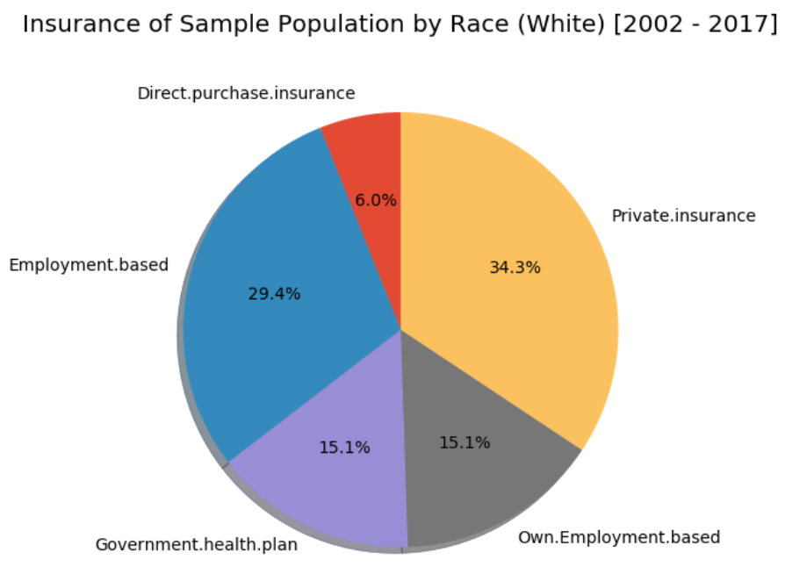

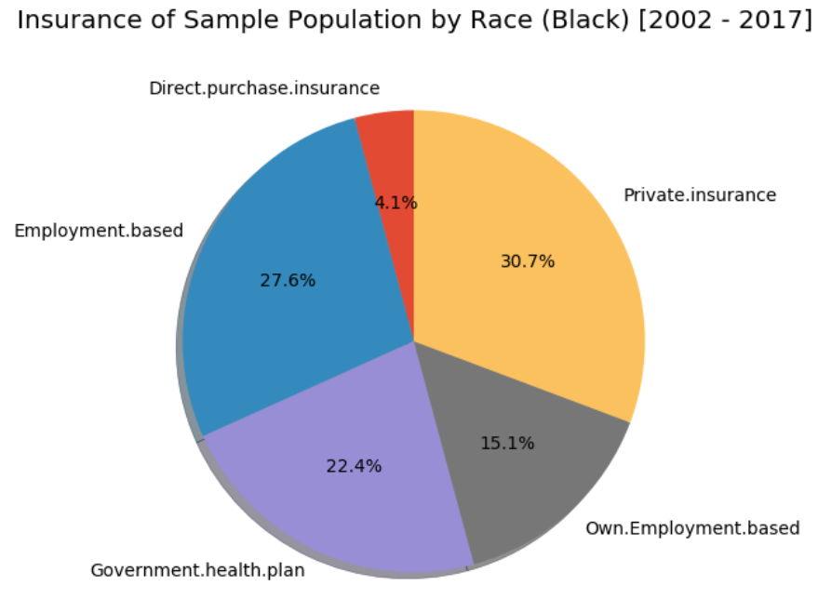

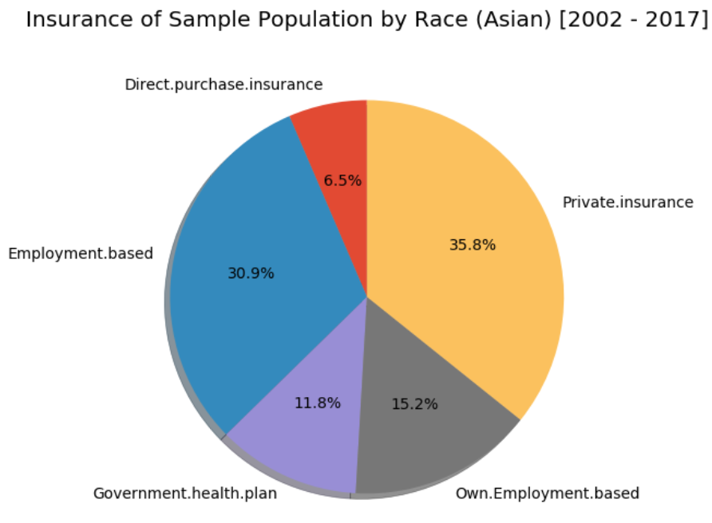

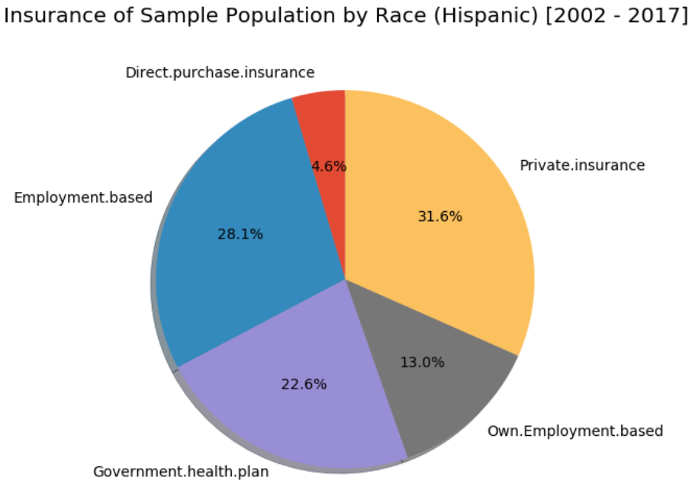

In the above graphs, we find a distribution of insurance providers by type for each of the major races in the United States. The pies only represent the populations covered by health insurance. In the United States, where being on government assistance is seen as an option of the last resort, it is important to note how significantly more ‘Black’ and ‘Hispanic’ people have to rely on government assistance than ‘White’ and ‘Asian’. Insurance providers are weighted more towards employment-based providers and private insurance companies for White and Asian populations. While it is promising to know that the government is present in the United States as foundation for enabling mobility, it a mark of low mobility when we see over one-fifth of Blank and Hispanic populations insured through the government.

**Proportions Covered, by Race**

This next series of waffle charts are a bit more unintuitive. However, what they display is the proportions of each race within the total numbers of those insured, for the races – White, Black, and Hispanic. Interpreting these graphs requires some amount of caution, since they are again proportions of a total. And anytime total numbers of one group far outweigh those of another, it is important to be judicious.

The first graph represents the population of those covered. The color blue represents ‘White’, the color white represents ‘Black’, and the color red ‘Hispanic’. What we see is that nearly 3.5 millions of the population in the representative sample covered by health insurance is White, and that somewhere around 500,000 of the covered population is Black, and Hispanic respectively.



The below graph shows the population that is not covered. A waffle chart using absolute numbers is interpreted based on the area of its blocks for each category. Thus, below we see that about 500,000 White Americans were without health insurance between 2002 to 2017, and that 100,000 Blacks, and over 200,000 Hispanics were not covered during the same time.



**Medical Coverage Trends Over the Years**

Finally, in what can only be called a crescendo and a grand finale, we plot the numbers for the aggregate numbers of those insured in our sample. The numbers are doubtlessly promising, as they show a rising steady upward march.

There is however a slight anomaly in the graph, namely a marked dip in the aggregate numbers of people insured around 2008 to 2014, that is, for 3/4 of President Obama’s two-term presidency. This applies to all races alike, and is appalling given the emphasis by the administration on healthcare, then dubbed Obamacare. This may just be a typical example of unintended consequences, but the declines in medical coverage is most pronounced for Whites races.

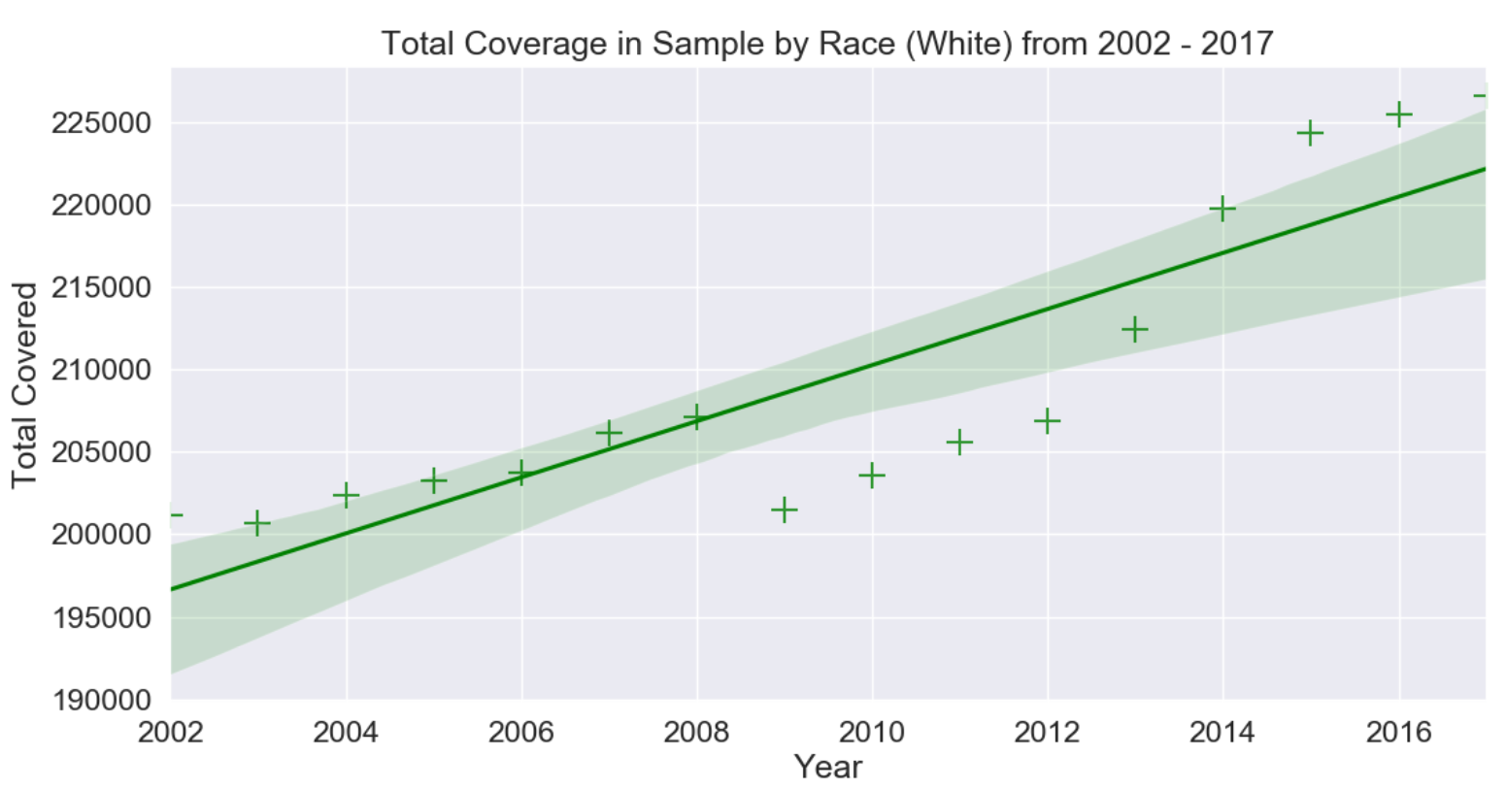

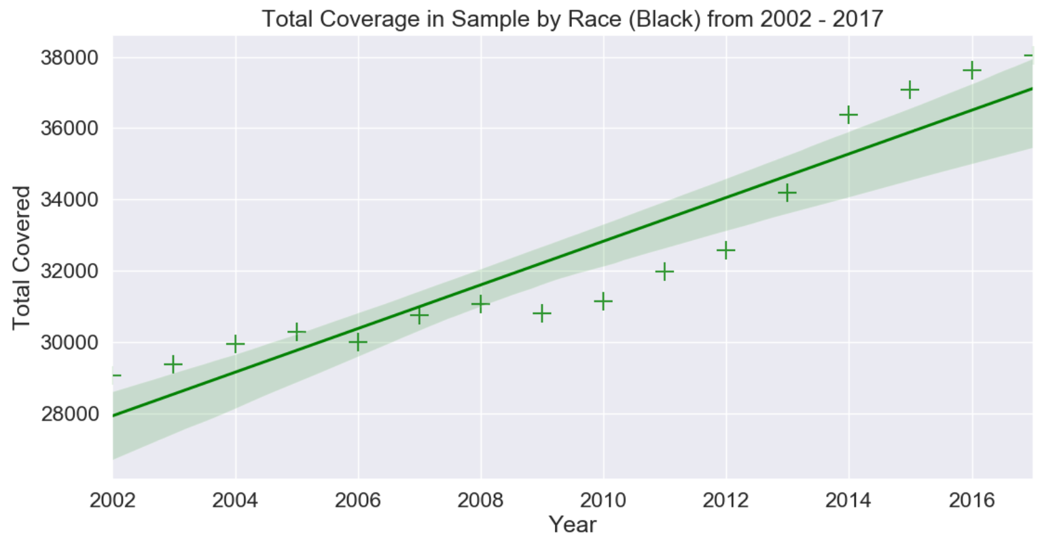

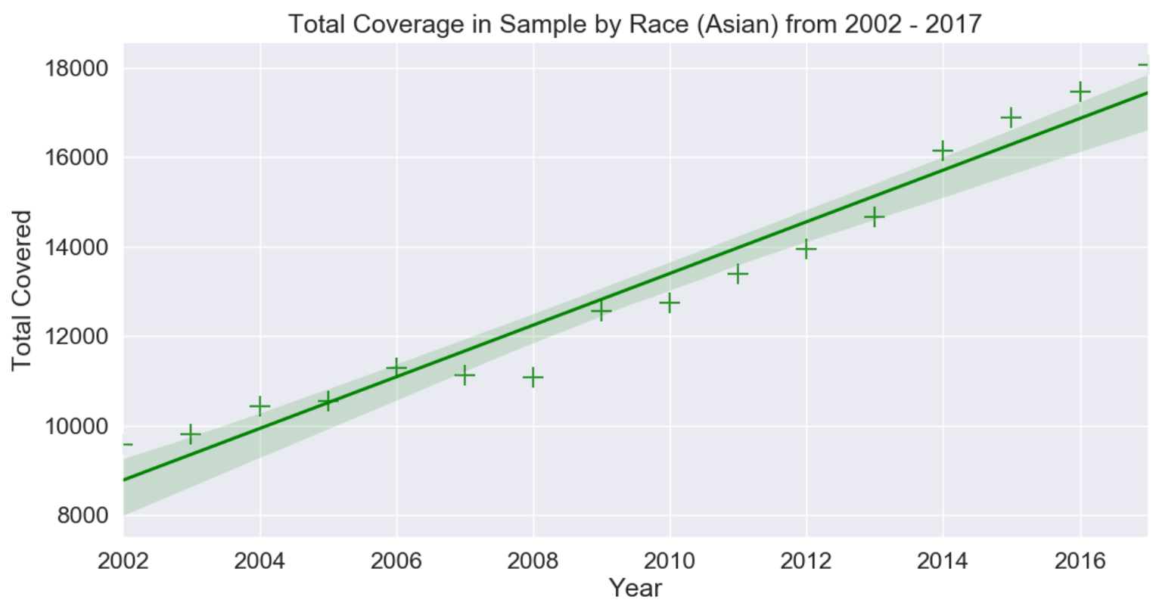

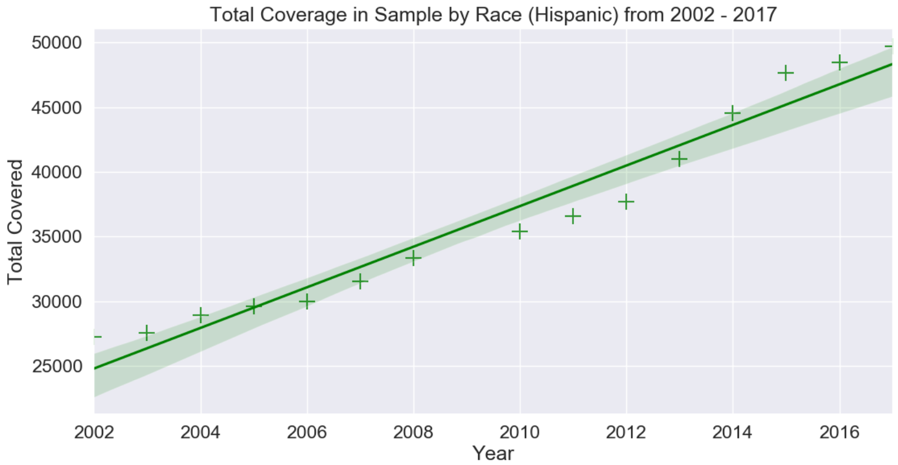

The American government spends nearly 17% of its GDP on healthcare. The healthcare system in the US is extremely complex and is defined by an intricate web of relations with differing interests and metrics of success. There are often perverse incentives when monolithic pharmacy companies, reaping gains from short lived first to-market monopolies, reward care providers for prescribing their products. It is therefore important to be a healthy skeptic just as much as it is to be a healthy individual. And it would do us well to take a more collaborative approach with our care providers.